Biography and Qualifications
For the last 30 years, Sanmay has attended various Yoga lineages like Iyenger, Vinyasa, Hatha Yoga, Bikram and Patanjali Yoga. He has attended courses in USA as well as India. From his childhood, Sanmay grew up in the yogic culture and was initiated into yoga using Bisthu Ghosh’s traditions. Though introduced to the therapeutic aspects of yoga at a very early age, Sanmay eventually took up health/wellness and disease management using yoga for the last 10 years. He has been teaching Yoga for the last 15 years and teaches in India, regularly in USA including major corporations like County of Los Angeles. Sanmay studies and specializes in ancient scriptures to create the foundation for his yogic journey.
Sanmay has launched a major Yoga based disease management App called “DrYogi”. The app is free with the goal to reach every house hold in the world. Most of the proceeds from his Yoga Therapy and general sessions go in helping poor people in USA and India. Sanmay also works with Homeless people in USA as well differently abled people. His yoga is simple, can be done at any age, and any mobility. He uses creative modification techniques.
Sanmay, in collaboration with a network of therapists globally, has treated a lot of people with backpain, neck pain, knee pain, heart disease, BP, Asthma and lung diseases, Cancer, Autoimmune, arthritis, IBS, Ulcers, Eye diseases, Speech impairments, and Stroke. He works with physicians, Yoga therapists, and creates yoga sequences custom tailored for Individuals. He also takes classes to educate patients to become self-managed.
Sanmay is full time Yoga practitioner who held a Senior Executive position in a Large firm in USA. This experience was instrumental in designing Corporate programs on Stress and Anxiety. He works also with corporations to improve health, stress, and depression to improve corporate efficiencies. He is in the process of collaboration with clinics and hospitals on Pain management, lung diseases and cancer. His YouTube channel is appropriately called “The Techie Takie Yogi.” (https://www.youtube.com/channel/UC2YyZglpD12GHxaVm1iZdFw?)
He has presence in FB, Twitter, and LinkedIn.
Education:
B.Sc. (Physics); B. Tech, M. Tech (EE/CS); MBA (Finance); M.Sc. (Yoga); PGDYT (Yoga Therapy); C-IAYT
CNN report on Sanmay’ s University:
https://www.youtube.com/watch?v=qOCLRvxgj_M&feature=youtu.be&fbclid=IwAR31iwQwpx1PWoMClUFnOUqyJhdiTLFNV0h9el9Z5UvqMPaks0K9eJaojTQ .

Yoga Research topics:
“Impact of an Integrated Yoga protocol on IgG4 an autoimmune marker.”
Paper on Yogic Interoception for Cancer diagnostics – a Case study.
Specialized Programs:
Numerous programs on different disease management – obesity, diabetes, cancer, autoimmune, IVF and Pregnancy, Stress Management. Therapy classes on theory and practice of Yoga Therapy for different disease groups.
Specializes in chair yoga for Senior population. Yoga mindfully modified for people who need to do it sitting on the chair.
Speaker on Consciousness, Yoga and Artificial Intelligence. Speaker on science and consciousness and how yoga fits in.
Corporate Stress Management program. 4 hours to 2 day program on how to reduce stress at work. How to manage time and mind for effectiveness at work.
Creator of several breath-based meditation programs. Where breath is used to garner transcendental experience.
Multiple levels of Pranayama and Meditation practices to mitigate stress, improve health and lead a confident life.

General offerings:
General Yoga
Simple Pranic Flow (Breath based)
Yoga for long life for 50+
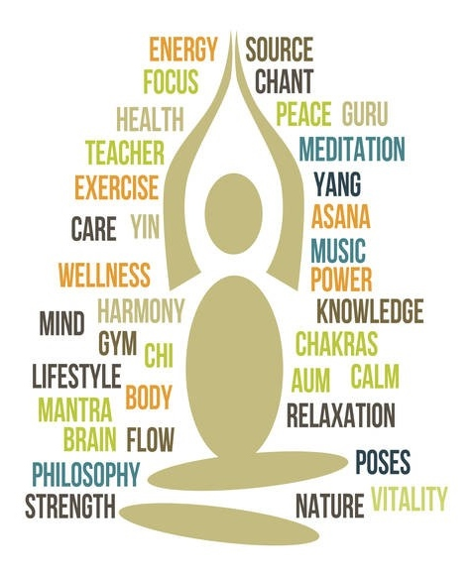
Basic Pranayama and Meditation
Specialized Breath and Meditation:
Intermediate Meditation
Sound Meditation
Jyotir Meditation
Chakra Meditation
Advanced Meditation
Advanced pranic flow
Yoga for Vagus stimulation
Disease Management:
Therapy sessions focusing on spinal health, cancer, autoimmune, anxiety and depression.
Class: (virtually and physically)
Yoga and disease management
Specialized classes for diseases
Specialized classes for Anxiety and Depression
Corporate:
Corporate efficiencies and Yoga
……………………………..And more……………….

